OOP LAB-03 TASKS

NOTE: Tasks .java file is uploaded in compressed folder in gcr and github link is also shared

TASK 1:

class Student {
private int rollNo;
private String name;
private double marks;

//setter
public void update(int rollNo, String name, double marks){
this.rollNo = rollNo;
this.name = name;
this.marks = marks;
}
//getter
public int getRollNo(){ return rollNo; }
public String getName(){ return name; }
public double getMarks(){ return marks; }

//method
public String calculateGrade() {
if (marks >= 80) return "A";
else if (marks >= 70) return "B";
else if (marks >= 60) return "C";
else if (marks >= 50) return "D";
else return "F";
}

public void displayDetails(){
System.out.println("Roll No: " + rollNo + " | Name: " + name + " | Marks: " + marks + " | Grade: " + calculateGrade());
}

}

public class task1{
public static void main(String[] args){
Student s1 = new Student();
Student s2 = new Student();
Student s3 = new Student();

s1.update(3012, "Owais", 90);
s2.update(3021, "Daniyal", 76);
s3.update(3058, "Ali", 54);

s1.displayDetails();
s2.displayDetails();
s3.displayDetails();
}
}

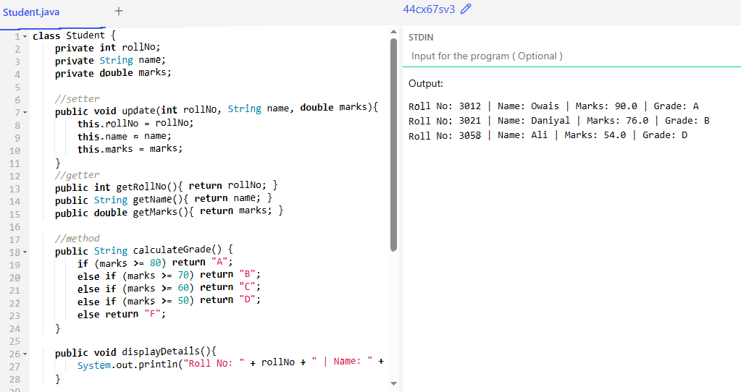
Task 1 (Output):

TASK 2:

import java.util.Scanner;

class Item {
public String itemName;
public int itemID;
private float price;
private int stock;
public String search;

//setter
public void update(float price, int stock){
this.price = price;
this.stock = stock;
}

//getter
public float getPrice(){ return price; }
public int getStock(){ return stock; }

//methods
public void purchase(int qty){
if(qty > this.stock){
System.out.println("Insufficient Stock!");
}
else{
float total = qty * price;
stock -= qty; // Update stock
System.out.println("--- Bill ---");
System.out.println("Item: " + itemName);
System.out.println("Total Price: " + total);
System.out.println("Remaining Stock: " + stock);
}
}

public void bill(){

}
}

public class task2 {
public static void main(String[] args){
Scanner sc = new Scanner(System.in);
Item i1 = new Item();
Item i2 = new Item();

i1.itemName = "Whey rotein";
i1.itemID = 123;
i1.update(1000, 5);
i2.itemName = "Creatine";
i2.itemID = 321;
i2.update(2000, 10);

System.out.println("Search for an item to purchase: ");
String search = sc.nextLine();

if(search.equalsIgnoreCase(i1.itemName)){
System.out.println(i1.itemName + " : PKR " + i1.getPrice());
System.out.println("Enter quantity to buy: ");
int qty = sc.nextInt();
i1.purchase(qty);
}
else if(search.equalsIgnoreCase(i2.itemName)){
System.out.println(i2.itemName + " : PKR " + i2.getPrice());
System.out.println("Enter quantity to buy: ");
int qty = sc.nextInt();
i2.purchase(qty);
}
else{
System.out.println("Item not found!");
}

sc.close();
}
}

Task 2 (Output):
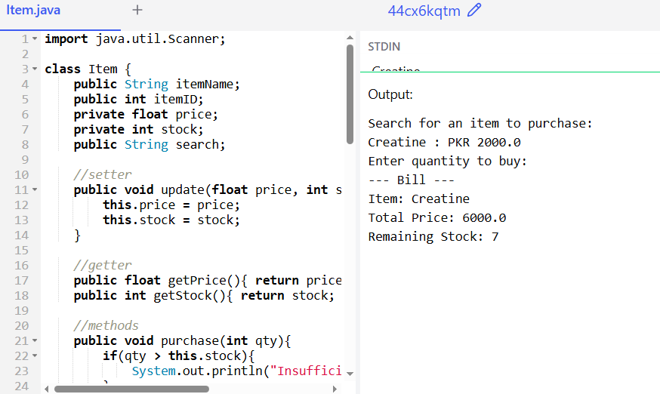

TASK 3:

class Student {
private int rollNo;
private String name;
private double marks;
private int attendance;

//setter
public void setStudent(int rollNo, String name, double marks, int attendance){
this.rollNo = rollNo;
this.name = name;
this.marks = marks;
this.attendance = attendance;
}

//getter
public int getRollNo(){ return rollNo; }
public String getName(){ return name; }
public double getMarks(){ return marks; }
public int getAttendance(){ return attendance; }

public void calculateResult(){
if(marks >= 40 && attendance >= 75){
System.out.println("Pass");
}
else{
System.out.println("Fail");
}
}

public void displayDetails(){
System.out.println("Roll no : " + rollNo);
System.out.println("Name : " + name);
System.out.println("Marks : " + marks);
System.out.println("Attendance : " + attendance);
}
}

public class task3 {
public static void main(String[] args){
Student s1 = new Student();
Student s2 = new Student();
Student s3 = new Student();

s1.setStudent(123, "Ali", 75, 80);
s2.setStudent(321, "Sherry", 78, 74);
s3.setStudent(542, "Owais", 90, 45);

s1.calculateResult();
s1.displayDetails();
s2.calculateResult();
s2.displayDetails();
s3.calculateResult();
s3.displayDetails();
}
}
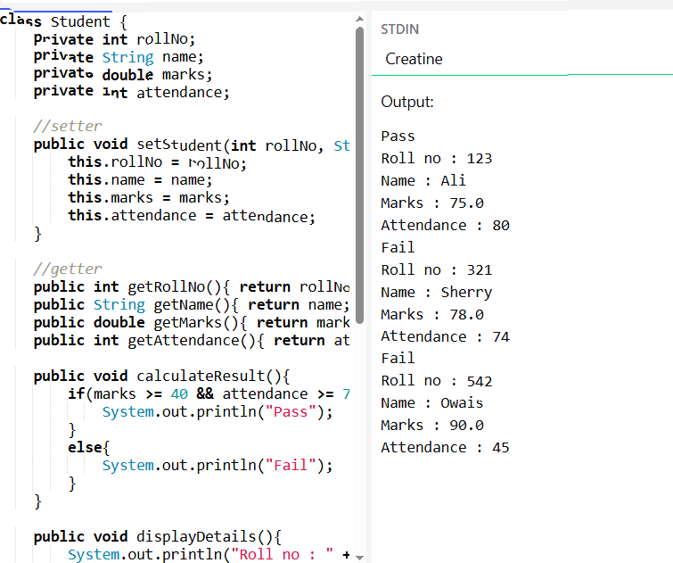
Task 3 (Output):
TASK 4 (Output):

import java.util.Scanner;

class Member {
private int memberID;
private String name;
private double currentWeight;
private double previousWeight;
private int workoutHours;

// Setters
public void setMemberID(int id) { this.memberID = id; }
public void setName(String name) { this.name = name; }

// We set the initial weight first, then the updated weight
public void setInitialWeight(double weight) { this.previousWeight = weight; }
public void setWeight(double newWeight) { this.currentWeight = newWeight; }
public void setWorkoutHours(int hours) { this.workoutHours = hours; }

// Getters
public int getMemberID() { return memberID; }
public String getName() { return name; }
public double getWeight() { return currentWeight; }
public int getWorkoutHours() { return workoutHours; }

public void assessProgress() {
// Task Requirement: hours >= 10 AND weight decreased
if (workoutHours >= 10 && currentWeight < previousWeight) {
System.out.println("Result: Good Progress");
} else {
System.out.println("Result: Needs Improvement");
}
}

public void displayDetails() {
System.out.println("\n--- Member Details ---");
System.out.println("ID: " + memberID + " | Name: " + name);
System.out.println("Previous Weight: " + previousWeight + "kg");
System.out.println("Current Weight: " + currentWeight + "kg");
System.out.println("Workout Hours: " + workoutHours);
}
}

public class task4 {
public static void main(String[] args) {
Scanner sc = new Scanner(System.in);
// Creating an array to hold 3 Member objects dynamically
Member[] members = new Member[3];

for (int i = 0; i < members.length; i++) {
members[i] = new Member(); // Create the object in the array

System.out.println("\nRegistering Member " + (i + 1) + ":");
System.out.print("Enter ID: ");
members[i].setMemberID(sc.nextInt());
sc.nextLine(); // consume newline

System.out.print("Enter Name: ");
members[i].setName(sc.nextLine());

System.out.print("Enter Initial Weight: ");
members[i].setInitialWeight(sc.nextDouble());

System.out.print("Enter Current Weight: ");
members[i].setWeight(sc.nextDouble());

System.out.print("Enter Workout Hours: ");
members[i].setWorkoutHours(sc.nextInt());
}

// Displaying all details and assessments
System.out.println("\n======= FINAL ASSESSMENT REPORT =======");
for (Member m : members) {
m.displayDetails();
m.assessProgress();
}

sc.close();
}
}

TASK 4 (Output):

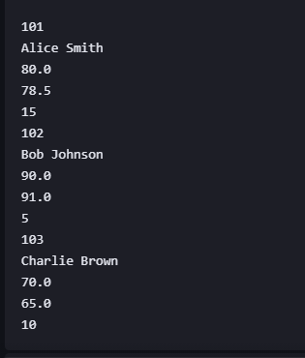

Registering Member 1:
Enter ID: Enter Name: Enter Initial Weight: Enter Current Weight: Enter Workout Hours:
Registering Member 2:
Enter ID: Enter Name: Enter Initial Weight: Enter Current Weight: Enter Workout Hours:
Registering Member 3:
Enter ID: Enter Name: Enter Initial Weight: Enter Current Weight: Enter Workout Hours:

======= FINAL ASSESSMENT REPORT =======

--- Member Details ---
ID: 101 | Name: Alice Smith
Previous Weight: 80.0kg
Current Weight: 78.5kg
Workout Hours: 15
Result: Good Progress

--- Member Details ---
ID: 102 | Name: Bob Johnson
Previous Weight: 90.0kg
Current Weight: 91.0kg
Workout Hours: 5
Result: Needs Improvement

--- Member Details ---
ID: 103 | Name: Charlie Brown
Previous Weight: 70.0kg
Current Weight: 65.0kg
Workout Hours: 10
Result: Good Progress

